ITEC PROGRAMME ON
Project & Risk Management
03rd to 21st February, 2020

About NIFM
The National Institute of Financial Management (NIFM) is a Centre of Excellence specializing in capacity building of professionals in the fields of Public Policy, Financial Management and other governance issues for promoting highest standards of professional competence and practice. NIFM is a premier resource center for the capacity building of senior, middle and entry level of management in Government of India. NIFM also caters to the training needs of State Governments, Defence establishments, banks and other financial institutions. Training programmes are customized and executed for the officials from other countries as well.
NIFM plays a pivotal role in governance and administrative reforms by providing a platform for interaction and exchange of ideas & experiences among officers from different organized services, different state governments and between personnel of civil and Defence establishments.
programme aims to develop an integrated view of the different risks faced by an
organization.
Apart from capacity building, NIFM is also engaged in serious research studies in the areas of accounting, audit, financial management, parliamentary financial control and other issues related to public policy and delivery systems. The outcome of such research studies are published and disseminated through research papers, journals and books.
NIFM has a sprawling lush green campus of 42 acres situated in N.C.R having unique Architectural design. It has state-of -art lecture halls, computer labs, hostels, indoor and outdoor sports complex and library.

Objectives of the Programme
Through a critical examination of theory, research and best practices, you will develop a knowledge and understanding of how to measure and manage a number of risks and how to implement and contribute to an integrated risk management strategy within an organization. In order to be effective and efficient, the Operating Managers should be finance savvy, capable to drive and measure business plans in terms of financial figures, and be able to communicate in a common 'business language' through financial figures. Introductory programme on finance can be instrumental to enhance the profile of Operating Managers. Further, Operating Managers need to be equipped with financial decision making tool kit, which could help them in identifying risk, take pricing decisions, decide on the product mix, identify areas for cost reduction and take a make or buy decision. This programme aims to meet the requirements of the Operating Managers in different functional areas who in turn would equip themselves with the introductory nuances of finance.

2019-20

2018-19
2019-20

Pedagogy and Faculty
The methodology adopted for imparting training shall include presentations, discussions, case studies and field visits. Apart from NIFM’s own faculty, resource persons would include, senior academicians, experts from Public Sector Undertakings, senior Government officers, consultants and practitioners having vast experience in the relevant fields. Preeminence of faculty is one of the strong points of this training.

For Whom? (ITEC Countries) (https://www.itecgoi.in)
- Officials in Government, Public and Private Sectors, Universities, Chambers of Commerce and Industry etc.
- Candidates should possess adequate work experience.
- Academic qualifications: Graduate / Degree holder.
- Working knowledge of English required.
- Age between 25 to 45 years.

- Programme Contents
The programme is proposed to be divided into the following broad modules:

- Understanding and Analysis of Financial Statements

Balance Sheet

Profit and Loss Statement Cash Flow Statement
Use of Financial Ratios as key indicators

- Cost information for Problem Solving and Decision-Making

Types of costs

Understanding of cost behavior Establishing break - even levels Using costing for product pricing
- Management of Working Capital Estimation of working capital needs Working capital cycle
- Evaluation of Investment Projects Project cash flows: estimation Techniques of evaluation

Integrated View of Finance Function
2019-20

The Global Finance Environment

- Risk identification and assessment

- Risk as an opportunity for business growth

- Internal factors - financial and operational risks

- External factors - economic and environmental risks

- Functional Risk Management: Project, Product and Supply chains

- Developing an ERM framework
- Implementing an ERM strategy

- Internal controls and corporate governance

- Risk Intelligence and Analytics.

- Financial Arrangements
Under Government of India Sponsorship (ITEC)
The financial arrangements of the programme are as per the guidelines issued from time to time under Indian Technical and Economic Cooperation Programme of Government of India.
- Under Arrangements other than above / Self Financing Scheme
The per participant programme fee is INR 1,30,000/- + GST as applicable. It includes Tuition Fee, Course Material, Boarding and Lodging. It does not include to and fro journey to NIFM and per diem. Accommodation to the participants will be provided in the Hostel of the Institute. Duly filled nomination form(s) along with Demand Draft for INR 1,30,000/- + GST drawn in favor of ‘NIFM’ payable at ‘Faridabad’ may be sent to Programme Director (MDP), NIFM, Sector - 48, Pali Road, Faridabad-121001, Haryana.

- Closing Date For Nominations:
Twenty days before the commencement of the programme.

- Venue and Reporting
National Institute of Financial Management (NIFM), Sector-48, Pali Road, Faridabad – 121 001, Haryana. It is located in Faridabad town on Badkhal–Pali Road, about 1 km south of Badkhal Lake crossing.
NIFM is at a distance of about 30 kms from India Gate, New Delhi and about 35 kms from Delhi Airport. Participants are expected to reach NIFM one day before commencement of the programme and proceed for their return journey within a day after conclusion of the programme.

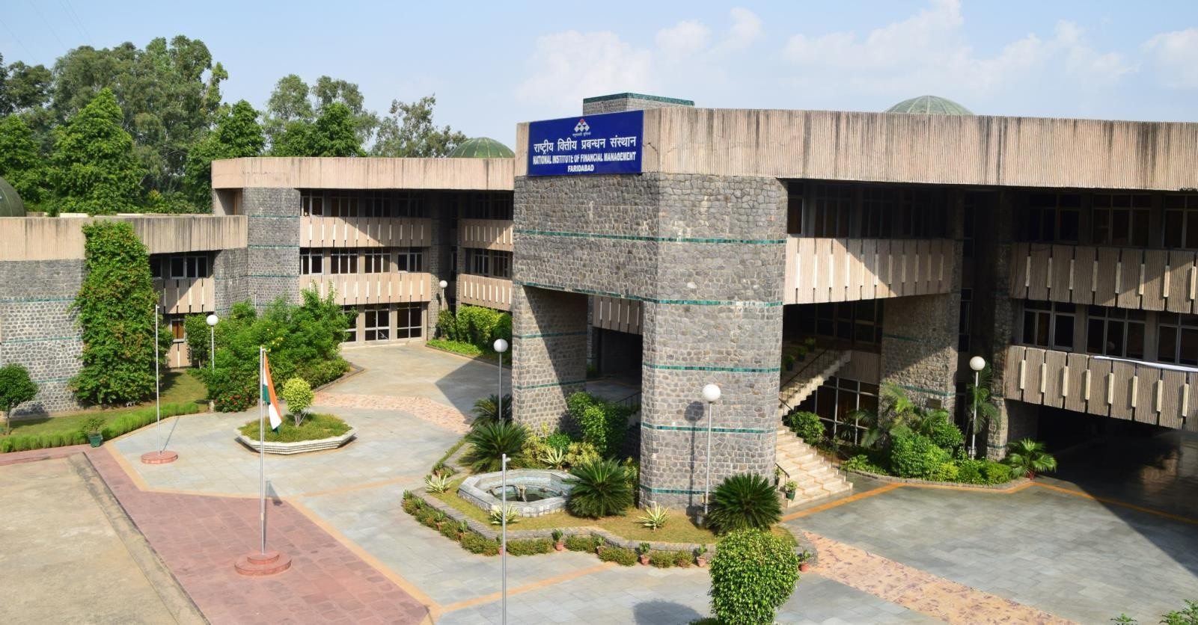
2019-20

Head of the Institute: | Please do write to us!
Mrs. Meena Agarwal
Tel. No. : + 91 129 2418870
Fax: No. : + 91 129 2418867
Email : director@nifm.ac.in
Course Director:
Dr. Brajesh Kumar, Associate Professor
Tel. No. : + 91 129 2465209
Telefax: No. : + 91 129 2418891
Email : brajesh@nifm.ac.in
MDP Cell :- mdpcell@nifm.ac.in
Tel. No. : + 91 129 2465259

National Institute of Financial Management
An autonomous Institute of Ministry of Finance, Government of India
+ 91 - 129 - 24 65 44 4 (P hon e)
+ 91 - 129 - 24 18 867 (F a x)
Sect or - 48, Pal i Road, Near Badkhal Lake Faridabad, India - 121 001
www.nifm.ac.in

