ABOUT THE PROGRAMME
The right to adequate housing was recognized as part of the right to an ‘Adequate Standard of Living’ in the 1948 Universal Declaration of Human Rights (UDHR, article 25 (1) ) and in the 1966 International Covenant on Economic, Social and Cultural Rights (ICESCR, art. 11). As per this, for housing to be adequate, it must provide more than four walls and a roof, and at a minimum, meet the seven key criteria, such as : (i) Security of tenure; (ii) Availability of services, materials, facilities and infrastructure; (iii) Affordability; (iv) Habitability; (v) Accessibility; (vi) Location; and (vii) Cultural adequacy. The aim of the course is to provide the participants the concepts related to the rights-based approaches of adequate housing, especially adequate and affordable housing for urban poor population and suggestive methods for supply of it in the increasing global urbanization.

ABOUT HUDCO AND HSMI
Housing and Urban Development Corporation Ltd. was set up in 1970 by the Government of India to accelerate the pace of housing and urban development in the country. It is a Government company with more than 48 years experience in providing loans for housing and urban infrastructure projects in India. HUDCO has established itself as a premier techno-financing company. Apart from the financing operations, HUDCO offers consultancy services, promotes research and studies related to urban development and supports the Govt of India in its various Housing and urban development related programmes and policies.

HUDCO’s Human Settlement Management Institute (HSMI) is the research and training wing of HUDCO, a Govt of India undertaking under the Ministry of Housing and Urban Affairs, HSMI provides training for professionals on a variety of issues of housing, urban and regional planning and development. HSMI has considerable experience of conducting short term training programmes and has its own well equipped training facilities including Hostel. So far, it has conducted 41 ITEC programmes in which about 900 participants have been trained.
Under International Technical and Economic Cooperation (ITEC)
Sponsored By Ministry of External Affairs, Government of India
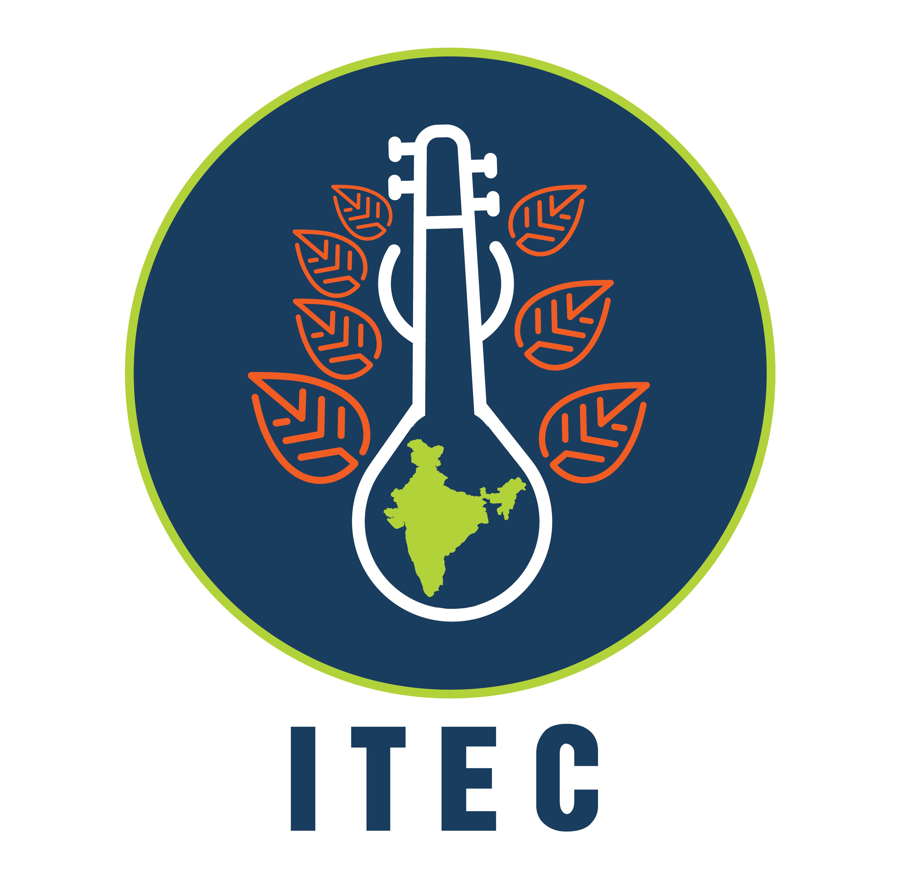
INTERNATIONAL COURSE FOR OVERSEAS PROFESSIONALS ON
REALIZING THE RIGHT TO ADEQUATE HOUSING IN THE CONTEXT OF HABITAT III NEW URBAN AGENDA
- POLICIES, PLANNING & PRACTICE

PLACE: NEW DELHI, INDIA

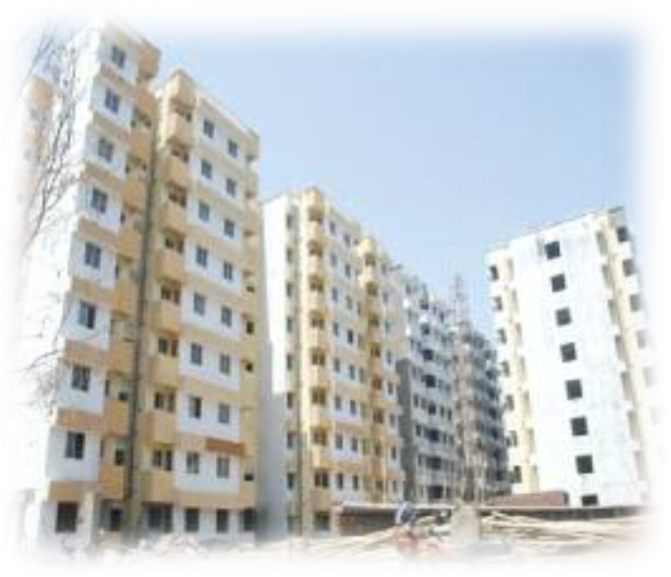

1st February- 12th March 2021
Venue of Training: HUDCO’s HSMI, Hudco House, Lodhi Road New Delhi – 110003
Phones: 91-11-41608297, 41708297, 49028297 | Email: edthsmi2013@gmail.com | www.hudco.org
TARGET GROUP
This programme is primarily designed for engineers, architects, town planners, landscape architects, urban designers, community development professionals, health workers, education and literacy campaigners and technologists working with national, provincial or urban local governments andother relevant institutions. Participation of Non-Government Organizations as well as some elected representatives, seriously engaged in urban affairs shall strengthen the interaction among managers of urban development.

HOW TO APPLY
Application should be made in prescribed format available with the Indian Mission in your country. The Indian Mission in your country will also be able to provide more details on the programme and information regarding the availability of fellowships. Please visit http://itec.mea.gov.in for details.

ELIGIBILITY
Participants should have at least a bachelor’s degree or equivalent in the mentioned disciplines with minimium 5 years of relevant experience. Preferred Age group 25-50 years
INTERNATIONAL TECHNICAL AND ECONOMIC COOPERATION (ITEC)
The Indian Technical and Economic Cooperation programme was instituted as a bilateral programme of assistance by the Govt of India in 1964. Over the last several decades, ITEC contributed substantially to capacity building in many parts of the world.. ITEC programmes have attracted thousands of participants from Asia, Africa, Latin America and Central Europe for training in a diverse range of subjects at a number of institutes across the country. Under ITEC, India provides development assistence to 162 developing countries from all over the world.
PROGRAMME OBJECTIVES AND OUTCOMES
The training is intended to help participants increase their knowledge and equip them with innovative tools and know-how for designing and implementing appropriate policies, approaches, programmes and interventions for access to adequate and affordable housing. The Key objectives of the programme:
- To sensitize various aspects of the New Urban Agenda, Sustainable Development Goals, and Paris Agreement for inclusive and equitable cities, with particular focus on provision of sustainable, adequate and affordable housing;
- To provide exposure through classroom study, and technical site visits of field issues and technical solutions to affordable housing issues; and
- To disseminate and share country policies, schemes, practices and innovative ideas and solutions related to supply of adequate and affordable housing to urban poor.
AIRPORT TRANSFER
This institute may arrange to receive the participants from the airport once the arrival details are received in advance. The arrival details may be sent to cpdhsmi@gmail.com. The details of pick-up arrangements shall be informed through email. The person deputed to receive will have the placard flashing the name of the institute “HSMI” and shall be available outside the terminal. Alternatively, on arrival, the participant can hire a prepaid taxi from the Delhi Airportt and indicate the Institute’s Hostel Address i.e.
F-212, Asian Games Village Complex (Khel Gaon),
August Kranti Marg,
New Delhi – 110 049.
The approximate tariff is around US $ 7- 10 .
In case of any problem in airport transfer, participants should contact the Institute’s Hostel. The telephone numbers of hostel are given below
PROGRAMME CONTENTS
The programme consists of six one week modules:
Module 1: Housing and Urban Development Policy frameworks and contexts.
Module 2: Rights-based Approaches to Planning for Affordable Housing at city level
Module 3: Aspects in design of affordable housing projects
Module 4: Learnings from Global experiences, Indian best practices and field examples of affordable housing projects
Module 5: Financing of affordable housing projects.
Module 6: Roadmap of reforms for Implementation of affordable (social) housing projects

TECHNICAL SITE VISITS
Structured visits to projects relevant to the programme will be organized to impart practical experience to the participants.

LANGUAGE OF THE COURSE
The course will be conducted in English

FELLOWSHIP
As per Government of India’s regulations indicated to the participants by respective Indian Mission under ITEC.

ACCOMODATION
Accommodation for participants is reserved in the hostel. Participants must NOT stay anywhere except at HSMI hostel. No reimbursement will be made to the participants if staying elsewhere, or for hiring of taxi. Institute’s hostel remains open round the clock on all days, including holidays.
DETAILS OF MATERIAL/ LITERATURE TO BE BROUGHT BY PARTICIPANTS
The programme is run on highly participative lines ensuring maximum involvement of the participants.. Each participant is required to make a presentation on country profile Participants will also be asked to undertake group exercises as part of the programme . In this context, selected participants are requested to bring relevant data and case studies covering the following:
Policy papers relating to housing, urban development, urbanization trends, status of urban infrastructure in their respective countries.
Country profile presentation for their country including:
- Location, area and demographic profile, socio- economic profile, planning and development, status of housing and infrastructure, currency, amd culture.
- Details of one city including social and economic profile, urban planning information, housing profile, access to basic services and infrastructure, Institutional arrangements and legal mechanisms currently operational in the country for undertaking housing and infrastructure development.
- Participants own work profile.
DELHI WEATHER
Winter arrives in Delhi by early December. During February, normal temperature is expected to be around 25 degree Celsius during the day and around 10 degrees Celsius in the night. The participants are advised to carry woollens with them.

HUDCO’s HUMAN SETTLEMENT MANAGEMENT INSTITUTE
(ISO 9001: 2015 CERTIFIED)
Head of Institute: Executive Director, Training,
Hudco House, Lodhi Road New Delhi – 110003
Email: edthsmi2013@gmail.com |
Tel: 91-11-24367834, 24308600
www.hudco.org

Hostel Address:
HSMI Hostel Complex, Khelgaon,
Phones: 011- 41608297, 41708297, 49028297 |
Fax Nos: 91-11-24365292

