Managing COVID 19 Pandemic- Experience and Best Practices of India

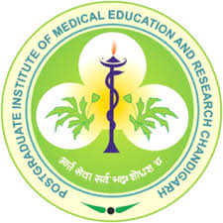
Organizers: Post Graduate Institute of Medical Education and Research, Chandigarh-India
under
International Public Health Management Development Program (IPHMDP)

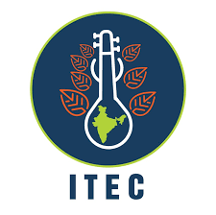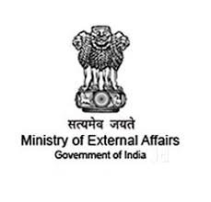
Supported by: ITEC Scheme, Ministry of External Affairs, Government of India

Context:
World Health Organization (WHO) reported 0.95 million confirmed cases and 40,598 confirmed deaths on 1st April 2020, which has drastically increased to 3.04 million cases and 211,000 deaths on 28th April 2020. The COVID-19 continues to spread across the globe transcending borders and cultures, which are affecting almost every country or territories. To contain the spread of virus, 82 nations have announced complete or partial lockdown (on 2nd April 2020), which was subsequently emulated by other nations.

Demonstrating India’s leadership, Hon. Prime Minister of India Mr. Narendra Modi invited leaders of the South Asian Association for Regional Cooperation (SAARC) through a virtual meeting (March 15, 2020) to discuss and coordinate efforts toward a regional response to the deadly outbreak. He also pledged an emergency fund of US$10 million to tackle and mitigate the risks associated with the coronavirus pandemic in the South Asian region. Later, during a video conference on March 26, he proposed to exchange best practices and experiences of India to different countries in order to combat the spread of COVID-19.

Indian Technical and Economic Cooperation (ITEC), Ministry of External Affairs, Govt. of India’ envision establishing relations of mutual concern and inter-dependence with ITEC countries on commonly held ideals and aspirations, and also building solid economic foundations. In this context, a capacity building program for ITEC countries on managing novel coronavirus (COVID19) has become important for collectively managing the global crisis. Since the administrators and decision makers play a key role in designing and implementing policy decisions, a program tailored to their needs is direly required at this juncture to update them on best practices and decisions taken by India in managing COVID19 crisis.

Aim:
Demonstration of best and replicable practices and experiences of India to healthcare administrators and decision makers of ITEC nations for managing COVID-19 pandemic in their respective countries.
Target Audience:
Healthcare Administrators –All ITEC Countries

Key highlights:
- Short duration sessions (2 hour program)
- Easy to access
- Practical and easily replicable
- Applicable for healthcare administrators in different settings
- Covering topics of common interest
- Learning’s from India’s experiences and best practices in handling the pandemic

Program Faculty:
Experts from Departments of PGIMER Chandigarh-India; Chandigarh Administration and Free Lance Experts

Program Director:
Prof. Sonu Goel, Department of Community Medicine & School of Public Health, PGIMER, Chandigarh

Program Duration:
18th May 2020; 2 Hours (one hour lectures + one hour panel discussion); Time: 15.00-17.00 hrs.

