Virtual Training course on Building Nursing Leadership for achieving Universal Health Coverage(UHC) and Sustainable Development Goals (SDG)

23rd to 25th March 2021

Duration: Three working Days (Tuesday to Thursday)

COURSE COORDINATING TEAM
Coordinator:  Co-Coordinator:  Course Associate: | Prof. (Mrs.) Rajni Bagga  Dr. Monika Saini  Dr. Vandana Bhattachrya  Dr. Ruchi Gaylong

The National Institute of Health and Family Welfare
In collaboration with MEA - eITEC
Munirka, New Delhi - 110067

BRIEF CONCEPT NOTE
INTRODUCTION
The World Health Organization (WHO) launched the 2020 Year of the Nurse and the Midwife campaign to celebrate the world’s 22 million nurses and 2 million midwives who make up half of the global health workforce. The year 2020 is dedicated to showcase the critical contribution of nurses and midwives to health care. Along with WHO, International Council of Nurses (ICN), International Confederation of Midwives, Nursing Now, and the United Nations Population Fund have partnered in running the campaign. This challenge, aims to work with healthcare employers worldwide, who between them will enable 20,000 young nurses and midwives to join leadership and development programmes and build their skills as practitioners, advocates and influential leaders in healthcare. It is aimed that building global leadership of this most important workforce will be crucially important to achieve the objective of sustainable development goals and universal health coverage by 2030.
The goal is to raise the profile and status of the nurses and midwives worldwide. Key areas for investment include employing more specialist nurses, making nurses central to primary health care.
Comprising over 50% of the world’s health workforce, nurses and midwives are the backbone of health care services, and they work at all levels of health care – from primary health care services within communities through to the most specialized levels of hospital care. Global nursing and midwifery leadership is essential to work in complex health system wherein multiple professional groups work together with interdisciplinary goals.
In order to prepare our nurses and midwives as global leaders, NIHFW makes an endeavor to organize an Online Training course on “Building Nursing Leadership for achieving UHC/ SDG (23rd to 25th March 2021) with an aim to build leadership competencies of Nursing professionals and build their skills as practitioners, advocates and influential leaders in healthcare so that they become proactive in successful implementation of new health reforms.
GENERAL OBJECTIVE
To build the leadership competencies of Nursing Professionals and build their skills as practitioners, advocates and influential leaders in healthcare so as to so become proactive in successful implementation of new health reforms.

SPECIFIC OBJECTIVES
At the end of the training course, the participants should be able:

- To explore their roles and responsibilities as per the challenges in achieving SDG and UHC
- To develop Leadership styles and skills and to move beyond current level of achievement by developing vision and setting new benchmarks.
- To learn to develop strategies for becoming a change agent for successful implementation of new health reforms.
- To acquire leadership skills for scientific decision making and problem solving approach.
- To develop an action plan for developing and applying the Leadership Skills for maximizing the potential of the available human power in the health sector for achieving the UHC and sustainable goals.

BROAD CONTENT AREAS

- Developing Self-Awareness and Building Emotional Intelligence
- Importance of building Leadership for strengthening Nursing
- Nursing Leadership for Strategic Vision Development towards a sustainable health system
- Nursing Leadership for achieving UHC
- Nursing Leadership for working towards SDG
- Developing Leadership styles and skills
- Leadership to build Motivation Skills for bringing desired change
- Nursing Professionals as Leaders- A Gender perspective’
- Leading with Vision and Setting Benchmarks
- Leadership for building and sustaining ‘Model Nursing management practices: integration of teaching and services
- Building partnership, Collaboration and Resource Mobilization
- Becoming a change agent for successful implementation of health sector reforms.
- Building Mentoring, Coaching & Counseling skills

Course Methodology
Though the training course would be conducted on virtual platform through following methods, efforts will be made to involve the participants in discussion and make two way communication:

- Presentations by Leading Experts
- Panel Discussion
- Participant Presentations
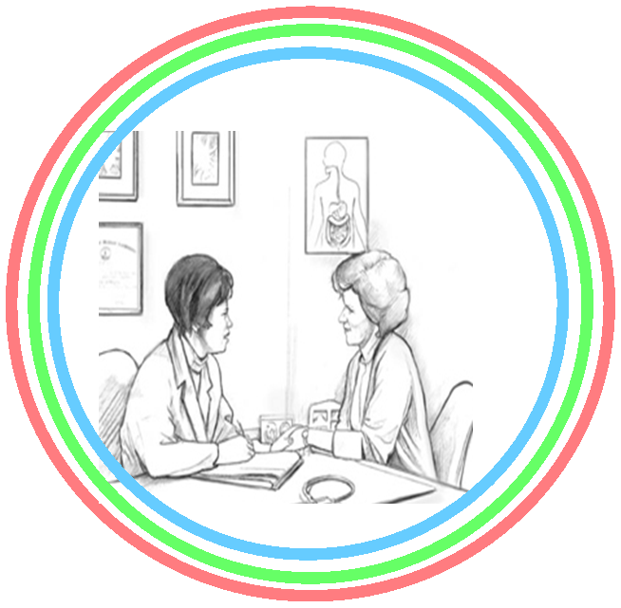
Nature of Participants
Participating countries can be from South Asia, Middle East, Africa, etc.
- Middle to senior Nursing health care professionals both from Central and State Health Service Institutions
- Middle to senior Nursing health care professionals from Hospitals, Teaching Institutions, Directorates, Regulatory bodies and Associations

Duration and Dates of the Course

- Duration: Three Days
- Proposed Tentative Dates: 23rd to 25th March 2021
Proposed Maximum Seats: 50 (Fifty) Seats
Mode of Evaluation of Performance of the Participants:
Both the Pre and Post Evaluation will be carried out Online by sending the E Form to the participants in advance.

Budget: For Preparation and Printing of Documentation and for the for the payment of honorarium to external resource Faculty, approximate budget of Rs.50,000/ may be required.

