INTERNATIONAL TRAINING PROGRAMME ON GEOINFORMATICS APPLICATIONS IN RURAL DEVELOPMENT

(1-28 March, 2023)

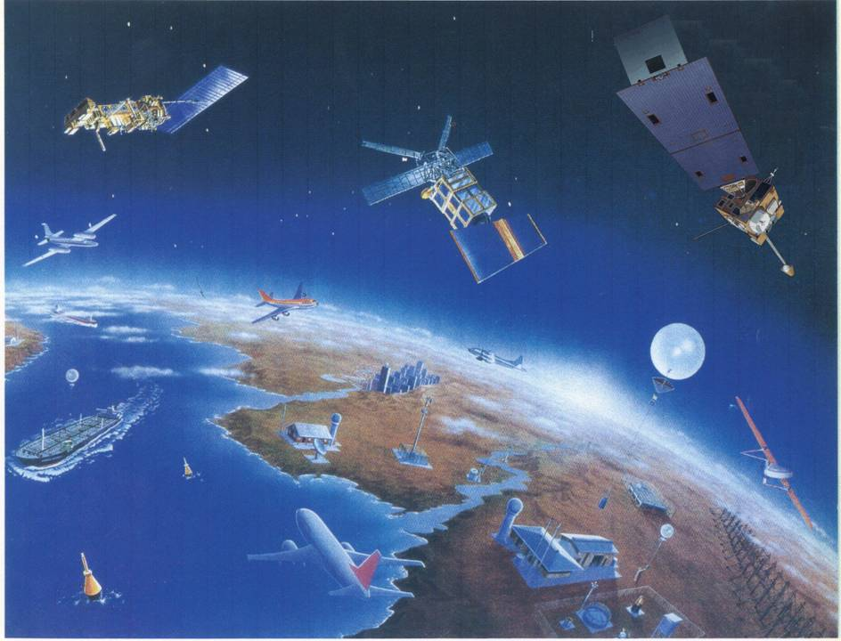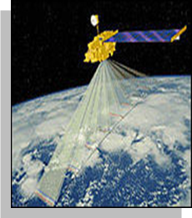

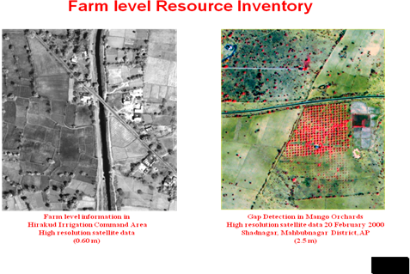

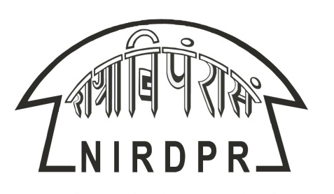

Centre on Geoinformatics Application in Rural Development (CGARD)

NATIONAL INSTITUTE OF RURAL DEVELOPMENT & PANCHAYAT RAJ
(An organisation of the Ministry of Rural Development, Government of India)
Rajendranagar, Hyderabad 500 030
Andhra Pradesh, India
Website: http://www.nird.org.in

GENESIS

Geo-Informatics is proving the ultimate parameter in decision making pertaining to location features and those associated with topography and terrain, slope, drainage and a host of related issues.

Thus Geo-Informatics holds great promise for ensuring reliability, appropriateness, cost effectiveness, real-time information base and such information has been accessible, affordable and usable at various levels.

It's high time the exposure on Geo-Informatics is shared and capacities developed for development functionaries from the developing countries to derive greater benefits of Geo-informatics Applications.

PROGRAMME OBJECTIVES

- To impart knowledge in the field of Geo-Informatics;
- To discuss various application potential of Geo-Informatics in rural development;
- To impart practical hands on experience to the participants on operating various commercial and open source software.

DESIGN:

The programme has been designed keeping in view the broad application potential of Geoinformatics in various fields and the technology trends which are forthcoming. The whole spectrum of Geoinformatic technology, process methodology, Software and Data products will be exposed and experimented with as Pilot Projects.

The following are the Modules for the International Geoinformatics Certificate Course:

Module - I

Concept, technology, applications and trends in Geoinformatics

The Geoinformatics technology concepts, technology trends and applications in form of Case Studies will be covered. The best practices and pilots will be discussed.
Module - II

Geographical Information Systems:

Data Models; Raster, Vector; Projections and transformations, geo-rectification, vectorisation, data bases, Editing, Spatial Adjustments, Analysis, Symbolization, Labels and Annotations, Graphs, Layout preparations, Network and Allocation Models, TIN, DEM, Slope, Aspect, Visibility Analysis, 3D Visualization, Hydrologic Analysis will be covered.

Module - III

Digital Image Processing and Photogrammetry

Data Products of Spatial Data, Satellites, Resolutions Applications, Image rectification, Sub setting, Mosaicing, Image Enhancement, Image classification, Resolution Merging, Ortho-photos, generation of 3D surface, Image draping and re-projection, Map composition. Preparation of Land use land cover and other thematic layers from satellite data will be covered.

Module - IV

Global Positioning System and Surveying

GPS/ DGPS/ Total station surveying and Mapping. Elevation Models, Inter-visibility, 3D Modeling, Surface Analysis, and interfacing with Google earth, Virtual GIS applications will be covered.

Module - V

Geo-informatics Applications, Web GIS and Study Visit

Participants will be exposed to various ongoing projects and programmes on Geoinformatic application across the country, policies, pilots, technology trends, and innovative approaches, appropriate for the developing world. Software customization for small applications, Web publishing of maps and other server & Web applications will be taught. Live case Studies and Simulated Exercises will also be exposed for firsthand experience on process and implementation of Geoinformatic Projects and Programmes in real life situations.

Module – VI

Project Report

A short term Project on any application of Geoinformatics will be assigned under the guidance of CGARD Faculty for having experience on working on a live project with Geo-informatics.

PARTICIPANTS

The programme is designed for International middle & senior level development Participants directly concerned with planning and implementation of Projects and Programmes for rural development viz. Sectoral Activities like Education, Health, Forestry, Agriculture, Engineering, Roads, Infrastructure, ICT, Irrigation, Drinking Water, Disaster Management, Planning, Monitoring, Fishing, Animal Husbandry and the like in developing countries, managers of rural development programmes / projects finance by World Bank, UNDP, FAO, IFAD and various other international organizations. The participants preferably should have proficiency in English and should be below 45 years of age.

What participants should bring

The Delegates are suggested to bring along with them a detail summarized presentation on Status of Geoinformatics in their respective countries and are also urged to bring Maps, geo- Statistics and alpha numeric Data sets for developing GIS coverage on their countries for use in their country after return to their countries after completion of the Training Programme.

FACULTY

The Centre on Geoinformatics Application in Rural Development (CGARD), NIRD&PR has Technically Qualified Multidisciplinary Scientific and Professional Team, highly qualified and experienced in all aspects of Geoinformatics, both in development and application modules, who will train the delegates. In addition eminent Geoinformatics Resource Persons, who have done considerable work in this field, too will be drawn for addressing the delegates and demonstrating various application modules.

PROGRAM TEAM

Dr P Kesava Rao, Dr M V Ravibabu and Dr. NSR Prasad of the Centre on Geoinformatics Application in Rural Development (CGARD), NIRD&PR.

BOARD AND LODGE

The training programme is fully residential. The Institute has well furnished Guest Houses for International Participants and has all facilities within the sprawling campus of NIRD&PR, at Rajendranagar, Hyderabad, India.

DURATION

Four Weeks (1-28 March, 2023)
PROGRAMME FEE AND FELLOWSHIPS

The Institute does not provide any financial support to International participants. But, the Government of India under ITEC, SCAAP and Colombo Plan mainly to promote International cooperation offers a good number of Fellowships. The modest amount of fellowship offered by the Government of India covers all expenses such as tuition fee, board and lodging expenses, International travel, field study, etc. However, no out-of-pocket expenses are admissible.

Those who wish to avail this opportunity can contact the Indian Embassy or High Commission accredited to their country for application form and other details. (www.itec.mea.gov.in)

The applications must be forwarded by the sponsoring organizations and should be sent through Indian Embassy/ High Commission in their respective countries. Candidates are advised to contact Indian Mission in his/her country and collect all the relevant information from them before coming to India.

HOW AND WHERE TO APPLY

The application for the Programme should be routed through the Offices of Indian Embassies/ High commissions with a copy to Dr P Kesava Rao, Programme Director, Centre on Geo-informatics Application in Rural Development (CGARD), National Institute of Rural Development & Panchayat Raj, Rajendranagar, Hyderabad 500030, India, Tele Fax: 91-40-24008447

E-mail: kesava.nird@gov.in

CONTACTS OF PROGRAMME TEAM

Dr. P Kesava Rao (kesava.nird@gov.in)
Associate Professor &Head (CGARD)

Dr. M V Ravibabu (mvravibabu.nird@gov.in)
Associate Professor (CGARD)

Dr. NSR Prasad (nsrprasad.nird@gov.in)
Assistant Professor (CGARD)

